Evaluation Development of Strengths (student) Name: ________________________ Class: __________ Date: ___________

Theme: ________________________________________________________






I felt : when I: ________________________________________

________________________________________
Happy Afraid Angry Sad Disgusted Surprised

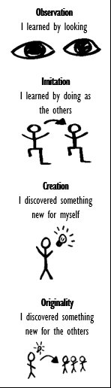
What we did: Goals of the lesson: I showed my strengths in: How did I learn?
O

O

O

O

Where I can improve:

O

O

O

What did I learn? ________________________________________________________________________________________________

Your challenges: _________________________________________________________________________________________________

Where you can improve: ___________________________________________________________________________________________

What do I need? _________________________________________________________________________________________________

What is my next step? ____________________________________________________________________________________________

